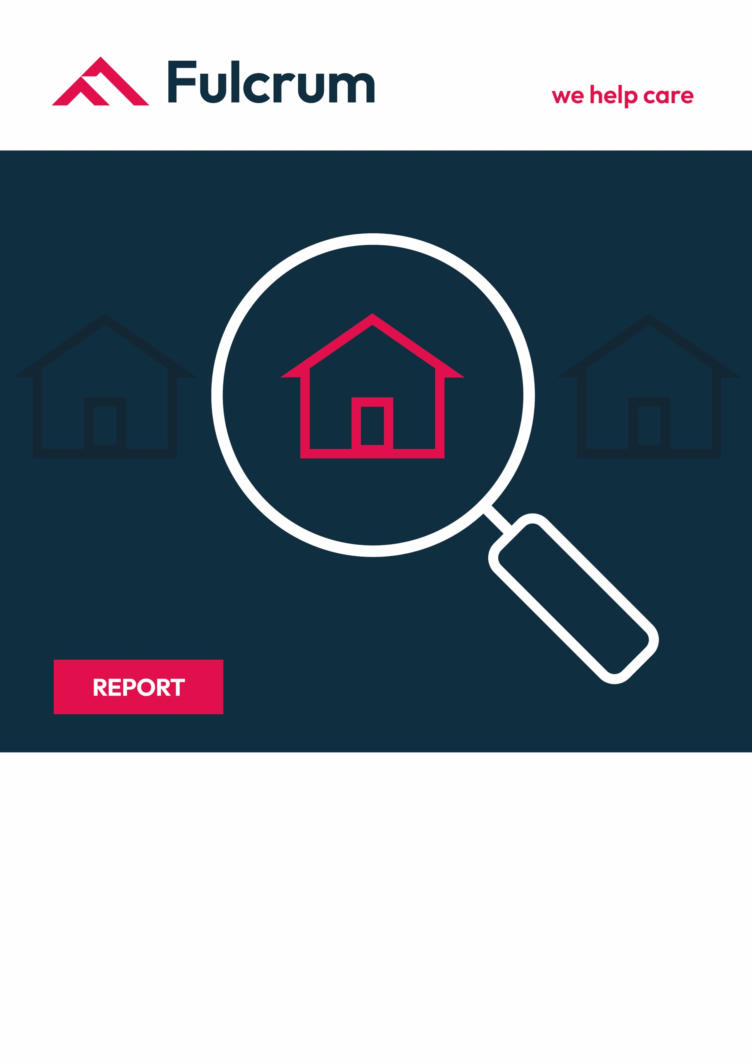
XXX Care Home
Address
Mini Mock Inspection

Date: DD/MM/YYYY

Introduction

The remote audit was completed by one of the consultants at Fulcrum Care who has experience in quality assurance.

We have highlighted through the report areas of recommendation.

This was based on the documents sent by the provider only no visit to the service was conducted. Therefore not all elements could be assessed.

Methodology

This audit focused on the evidence provided by the team at XXX Care Home.

We reviewed care plan records, governance activities, feedback surveys, training opportunities, accident/incident analysis, compliments and complaint information, and staff records.

Where we have seen evidence, we have cross-referenced this to the We statements and have made some recommendations about how the service can improve evidence collection.

SAFE
Learning Culture
CQC Quality Statement: We have a proactive and positive culture of safety based on openness and honesty, in which concerns about safety are listened to, safety events are investigated and reported thoroughly, and lessons are learned to continually identify and embed good practices.
Regs 12, 16, 17, 20

We reviewed the accident/incident analysis and whilst we could see that there was an effort made to review these, the information consisted of a list of time frames and numbers of falls.
There were a number of actions recorded that we would consider should have taken place when the accident occurred rather than as part of themes and trends.

For example, we noted that there were 3 falls in the corridor. We would have expected that these would be looked at in terms of the times, locations, and people involved to see what could be done to reduce the risk. This review could consider environmental factors, lighting, signage, allocation of staff, etc.

We could not see in the evidence provided that a lessons-learned approach has been taken as the actions from the previous month were not reviewed. We could see the intention to discuss this with the team but not the outcome.

We recommend: That the service develop a thematic review of accidents and incidents using a lesson-learned approach and review the previous month's actions as part of this review.

Safe Systems, pathways, and transitions
CQC Quality Statement: We work with people and our partners to establish and maintain safe systems of care, in which safety is managed, monitored, and assured. We ensure continuity of care, including when people move between different services.
Regs 12,17,9

We could not see from the care plans submitted that there were any pre-admission assessments completed or returns from the hospital.

Safeguarding
CQC Quality Statement: We work with people to understand what being safe means to them as well as with our partners on the best way to achieve this. We concentrate on improving people’s lives while protecting their right to live in safety, free from bullying, harassment, abuse, discrimination, avoidable harm, and neglect. We make sure we share concerns quickly and appropriately.
Regs 11,12,13,9,17,20

Not reviewed at this audit.

Involving people to manage risks
CQC Quality Statement: We work with people to understand and manage risks by thinking holistically so that care meets their needs in a way that is safe and supportive and enables them to do the things that matter to them.
Regs 9, 11,12,10

We reviewed risk assessments about two individuals in their care plan records. We could see that there were a variety of risk assessments that were pertinent not only to the individual but also to the environment such as hot water and hot drinks. We could also see that there was a PEEPS plan in place, but the information contained could have been expanded on to reflect additional risks such as emollient creams.

We noted in the individual risk assessments that some of the information in these, unfortunately, did not then reflect in the care plans. For example, the choking risk assessments did not contain enough information in terms of the type of thickener required and the reason for the swallowing difficulty.

One of the moving and handling risk assessments contained conflicting information and when checked against the care plan it appears it had not been updated following a change in condition.

Within the risk assessments we would have expected to see more detail about how the risk is managed, such as within the falls risk assessments for one person did not contain information about falls history, medical conditions that may impact such as osteoporosis, risk recognition for actual potential hazards and the detail of the equipment, type, how often used, etc.

We recommend: That individual risk assessments contain risk management information and detail about the specific individual requirements of the person and any safety equipment that is in use.

We also recommend: That the information from the risk assessments is transferred to the care plans.

Safe environments
CQC Quality Statement: We detect and control potential risks in the care environment. We make sure that the equipment, facilities, and technology support the delivery of safe care.
Regs 12, 15, 17

We could see evidence in the care plans that some environmental risks about individuals were considered in the care plans.

Safe and effective staffing
CQC Quality Statement: We make sure there are enough qualified, skilled, and experienced people, who receive effective support, supervision, and development. They work together effectively to provide safe care that meets people’s individual needs.
Regs 12, 18, 19

We had the opportunity to review 2 staff files, we could see evidence of appropriate application and taking of references.

We noted that there was a limited exploration of people's application and questioning at the interview. We noted on the job description that there was a reference to values it is unfortunate that on the model there were spelling errors and the document was poorly photocopied. The information included in the induction information was a list of policies.

We recommend: That the interview and induction pack be reviewed and that company documents be checked for accuracy to ensure they are well presented. It would be good to involve residents in the interview process.

Infection prevention and control
CQC Quality Statement: We assess and manage the risk of infection. We detect and control the risk of it spreading and share any concerns with appropriate agencies promptly.
Regs 12, 15,17

Not reviewed as part of the remote audit.

Medicines optimisation
CQC Quality Statement: We make sure that medicines and treatments are safe and meet people’s needs, capacities and preferences by enabling them to be involved in planning, including when changes happen.
Regs 9, 12, 11

Not reviewed as part of the remote audit.

EFFECTIVE
Assessing needs
CQC Quality Statement: We maximise the effectiveness of people’s care and treatment by assessing and reviewing their health, care, well-being, and communication needs with them.
Regs 9,12, 11,17

We could see in the care plans reviewed that there were regular reviews of the care plans, we could not see firm evidence that this was conducted with the resident or their family. We could see that they were completed monthly as an overview had been provided.

We recommend: That people take the time to provide a full review of all of the care planned and its effectiveness and include the views of the person and their family/legal representative.
Delivering evidence-based care and treatment
CQC Quality Statement: We plan and deliver people’s care and treatment with them, including what is important and matters to them. We do this in line with legislation and current evidence-based good practice and standards
Regs 9,12,14,17,11

We found that there was evidence that the principles of the Mental Capacity Act had been followed in the care plans reviewed. We could also see that there were efforts made to personalise the care plans to reflect people's preferences, likes, and dislikes. It was not clear the person's resuscitation status until the end-of-life care plan arrangements.

We recommend: That the care plans are further developed to reflect personalisation, independence, choice, and wishes.

How staff, teams, and services work together
CQC Quality Statement: We work effectively across teams and services to support people. We make sure they only need to tell their story once by sharing their assessment of needs when they move between different services.
Regs 9, 12, 17

We could see good evidence that the team in the home actively accesses external professionals to support people's care and outcomes.

Supporting people to live healthier lives
CQC Quality Statement: We support people in managing their health and well-being so they can maximise their independence, choice, and control. We support them to live healthier lives and where possible, reduce their future needs for care and support.
Regs 9,12,10

We noted in the care plans that there was evidence of conflicting information, and not all information was contained in the correct place.

For example, one resident has diabetes, and this was not reflected in the eating and drinking care plan. There was a lack of information about the type of equipment in use and conflicting information about mattress settings and the weight used to choose the setting.

We recommend: That the service manager audits the plans of care to ensure that the information throughout the plan is consistent.

Monitoring and improving outcomes
CQC Quality Statement: We routinely monitor people’s care and treatment to continuously improve it. We ensure that outcomes are positive and consistent and that they meet both clinical expectations and the expectations of people themselves.
Regs 17,9

We could not identify what supplementary charts were in use to support care from the care plans.

We recommend: That the use of supplementary charts, and the reason for them as well as what to do if there is an issue; for example, if a fluid target is not met, should be clearly recorded in the plan of care.

Consent to care and treatment
CQC Quality Statement: We tell people about their rights around consent and respect these when we deliver person-centred care and treatment.
Reg 11
We could see evidence that the service was considering the Mental Capacity Act within the care plans we reviewed.

CARING
Kindness, compassion, and dignity
CQC Quality Statement: We always treat people with kindness, empathy, and compassion and we respect their privacy and dignity. We treat colleagues from other organisations with kindness and respect.
Regs 9,10

We could see in the care plans that some of the people's individual needs were considered which indicated that the staff team knows people well.

Treating people as individuals
CQC Quality Statement: We treat people as individuals and make sure their care, support, and treatment meet their needs and preferences. We take account of their strengths, abilities, aspirations, culture and unique backgrounds, and protected characteristics.
Regs 9, 10, 15

The care plans would benefit from more detail such as in personal care regarding types of clothing, toiletries, hairdressing, etc.

There was a limited reflection of people’s culture in the care plans.
We recommend: That care plans are developed further to include additional person-centred information.
Independence, choice, and control
CQC Quality Statement: We promote people’s independence, so they know their rights and have choice and control over their own care, treatment, and well-being.
Regs 9,12,10

Within the care plans there was some information about how people were encouraged to make choices and how to keep them as independent as possible. This needed further development as it was not clear how the staff should support people.
We recommend: That care plans are further developed to establish how people are encouraged to make choices.

Responding to people’s immediate needs
CQC Quality Statement: We listen to and understand people’s needs, views, and wishes. We respond to these in that moment and will act to minimise any discomfort, concern or distress.
Regs 9,12,16

Not reviewed at the remote audit.

Workforce well-being and enablement
CQC Quality Statement: We care about and promote the wellbeing of our staff, and we support and enable them to always deliver person-centred care.
Regs 9, 12,17,18

Not reviewed at this audit.

Learning, improvement, and innovation
CQC Quality Statement: We focus on continuous learning, innovation, and improvement across our organisation and the local system. We encourage creative ways of delivering equality of experience, outcome, and quality of life for people. We actively contribute to safe, effective practice and research.
Reg: 17
We could see that the service was committed to the development of the staff team in the training plan. There were opportunities for condition-specific training and this was actively followed up.
We recommend: That this is linked with competency and reflective accounts to ensure that the learning was understood by all staff.

Environment sustainability-sustainable development
CQC Quality Statement: We understand any negative impact of our activities on the environment, and we strive to make a positive contribution in reducing it and support people to do the same.
Reg 17

Not reviewed at this audit.

Overall Summary
We found that although the documents reviewed contained the core processes to meet the regulatory requirements, there was work to be done to ensure that these were used to their full potential.

We have made some recommendations on concerns that should be reviewed or developed. We did identify some care plan issues that should be given attention, particularly as we saw conflicting or incomplete which could cause potential risks.

We saw good evidence that people's training needs were considered and that there was regular planned training and follow-up in place.

We also found that governance activities could be more focused and a lesson learned approach should be considered.
